**4COSC001W: Software Development I – TEST PLAN for Part 1**

Student Name/ID: J. A. Lakvindu Siriwardena - W1953896 - 20211125

Seminar Day/Time: Module Tutor: Mr. Saman Hettiarachchi

|  |  |  |  |  |  |
| --- | --- | --- | --- | --- | --- |
|  | **Student Name:** J. A. Lakvindu Siriwardena  **Student ID:** W1953896 / 20211125 | | | |  |
|  | **TEST PLAN for Part 1**  Submit completed test plan with your code solution | | | |  |
| **Test**  **Component** | **Test No.** | **Test Input** | **A - Expected Result** | **B - Actual Result**  **(or state ‘not attempted’)** | **Pass/Fail**  **(‘A’ matches**  **‘B’ == Pass)** |
| Progress | 1 | Pass = 120  Defer = 0  Fail = 0 | ‘Progress’ displayed | ‘Progress’ displayed | Pass |
| Progress  (module  trailer) | 2.1 | Pass = 100  Defer = 20  Fail = 0 | ‘Progress (module trailer)’ displayed | ‘Progress (module trailer)’ displayed | Pass |
| 2.2 | Pass = 100  Defer = 0  Fail = 20 | ‘Progress (module trailer)’ displayed | ‘Progress (module trailer)’ displayed | Pass |
| Module  retriever | 3.1 | Pass = 80  Defer = 20  Fail = 20 | ‘Module retriever’ is displayed | ‘Do not Progress - Module retriever’ is displayed | Pass |
| 3.2 | Pass = 60  Defer = 0  Fail = 60 | ‘Module retriever’ is displayed | ‘Do not Progress - Module retriever’ is displayed | Pass |
| 3.3 | Pass = 40  Defer = 80  Fail = 0 | ‘Module retriever’ is displayed | ‘Do not Progress - Module retriever’ is displayed | Pass |
| 3.4 | Pass = 20  Defer = 40  Fail = 60 | ‘Module retriever’ is displayed | ‘Do not Progress - Module retriever’ is displayed | Pass |
| 3.5 | Pass = 0  Defer = 60  Fail = 60 | ‘Module retriever’ is displayed | ‘Do not Progress - Module retriever’ is displayed | Pass |
| Exclude | 4.1 | Pass = 40  Defer = 0  Fail = 80 | ‘Exclude’ displayed | ‘Exclude’ displayed | Pass |
| 4.2 | Pass = 20  Defer = 0  Fail = 100 | ‘Exclude’ displayed | ‘Exclude’ displayed | Pass |
| Validation | 5.1 | Pass = a | ‘Integer required’ | ‘Integer required’ | Pass |
| 5.2 | Pass = 5 | ‘Out of range’ | ‘Out of range’ | Pass |
| 5.3 | Pass = 100  Defer = 40  Fail = 0 | ‘Total incorrect’ displayed | ‘Total incorrect’ displayed | Pass |
| Loops for multiple inputs | 6.1 | Program loops | Predicts multiple  progression outcomes | Predicts multiple  progression outcomes | Pass |
| 6.2 | Enter ‘q’ | Exits loop | Exits loop | Pass |
| Histogram | 7.1 |  | Progress 1 : *  Trailer 2 : **  Retriever 5 : *****  Excluded 2 : ** | Progress 1 : *  Trailer 2 : **  Retriever 5: *****  Excluded 2 : ** | Pass |
| 7.2 |  | 10 outcomes in total. | 10 outcomes in total | Pass |

**Principles I**

Test cases #1

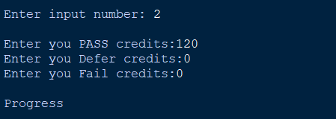

Test cases # 2.1

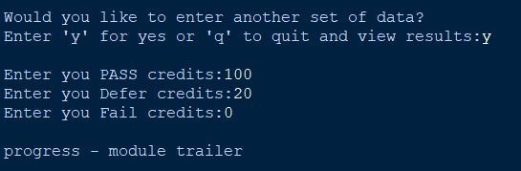

Test cases # 2.2

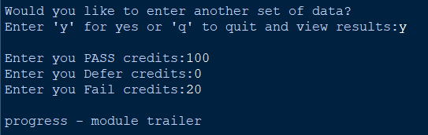

Test cases # 3.1

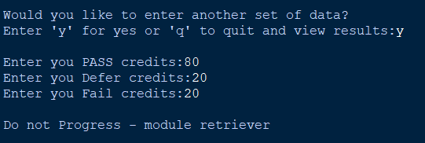

Test cases # 3.2

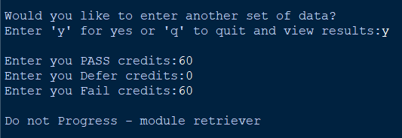

Test cases # 3.3

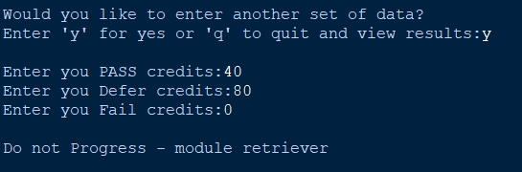

Test cases # 3.4

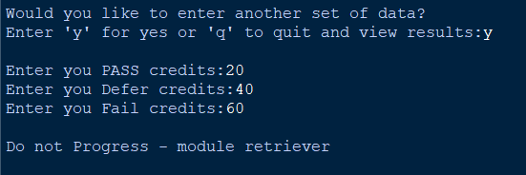

Test cases # 3.5

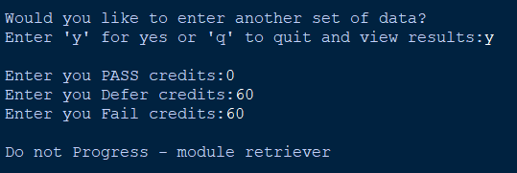

Test cases # 4.1

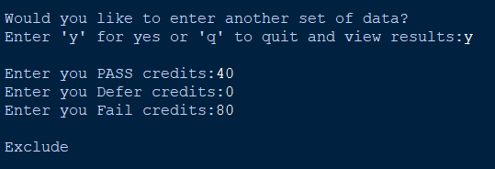

Test cases # 4.2

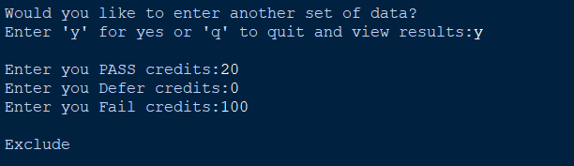

Test cases # 5.1



Test cases # 5.2



Test cases # 5.3

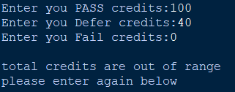

Test cases # 7

